**EXPERIMENT NO. – 9**

**AIM:** To Understand Continuous monitoring and Installation and configuration of Nagios Core, Nagios Plugins and NRPE (Nagios Remote Plugin Executor) on Linux Machine.

**LO:** LO1:- To understand the fundamentals of Cloud Computing and be fully proficient with Cloud based DevOps solution deployment options to meet your business requirements

LO5:- To identify and solve application vulnerabilities earlier and help integrate security in the development process using SAST Techniques.

**THEORY:**

### Nagios Core serves as the basic event scheduler, event processor, and alert manager for elementsthat are monitored. It features several APIs that are used to extend its capabilities to perform additional tasks, is implemented as a daemon written in C for performance reasons, & is designed to run natively on Linux/*nix systems

Nagios Core  formerly known as Nagios, is a [free](https://en.wikipedia.org/wiki/Free_software) and [open-source](https://en.wikipedia.org/wiki/Open-source_software) [computer](https://en.wikipedia.org/wiki/Computer)-[software application](https://en.wikipedia.org/wiki/Software_application) that [monitors](https://en.wikipedia.org/wiki/Event_monitoring) [systems](https://en.wikipedia.org/wiki/System_monitor), [networks](https://en.wikipedia.org/wiki/Network_monitoring) and infrastructure. Nagios offers monitoring and alerting services for servers, switches, applications and services. It alerts users when things go wrong and alerts them a second time when the problem has been resolved.

Nagios was originally designed to run under [Linux](https://en.wikipedia.org/wiki/Linux), but it also runs on other [Unix](https://en.wikipedia.org/wiki/Unix) variants. It is [free software](https://en.wikipedia.org/wiki/Free_software) licensed under the terms of the [GNU General Public License](https://en.wikipedia.org/wiki/GNU_General_Public_License) version 2 as published by the [Free Software Foundation](https://en.wikipedia.org/wiki/Free_Software_Foundation).

Nagios Remote Plugin Executor (NRPE) is a Nagios agent that allows remote system monitoring using scripts that are hosted on the remote systems.[[6]](https://en.wikipedia.org/wiki/Nagios#cite_note-6) It allows for monitoring of resources such as disk usage, system load or the number of users currently logged in. Nagios periodically polls the agent on remote system using the check_nrpe plugin.

NRPE allows you to remotely execute Nagios plugins on other Linux/Unix machines. This allows you to monitor remote [machine](https://en.wikipedia.org/wiki/Machine_(disambiguation)#Computing) metrics (disk usage, CPU load, etc.). NRPE can also communicate with some of the Windows agent add-ons, so you can execute scripts and check metrics on remote Windows machines, as well. As of 28 Jan 2020, NRPE has been deprecated.

**Output:-**

1. Create an instance of Nagios

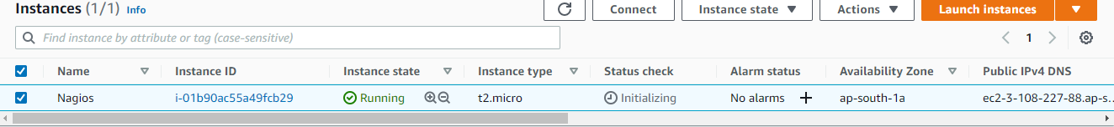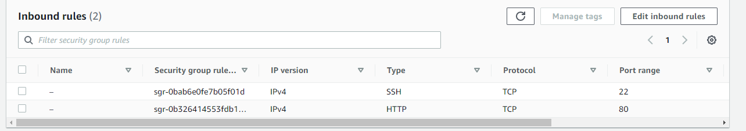

2) Connect to the instance

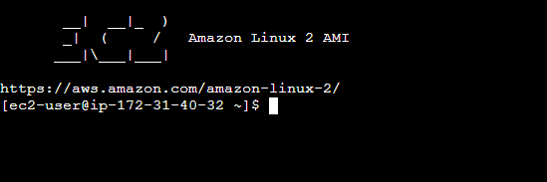

3) Install Nagios plugin

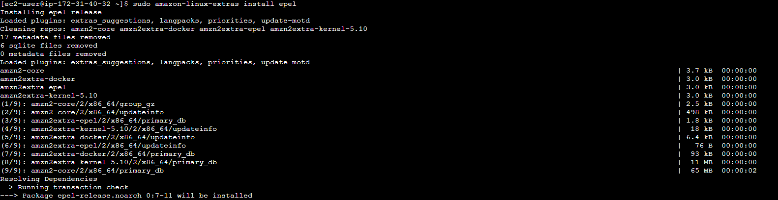

4) auto start nagios



5) install httpd and start httpd service

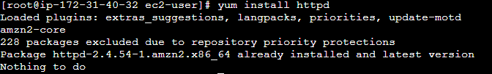

6) install php

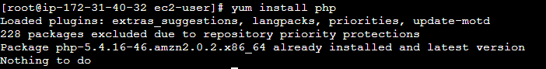

7) open the config.cfg and check nagios configuration

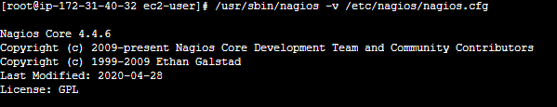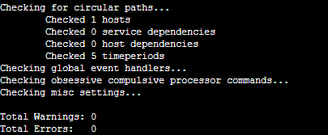

8) check nagios status

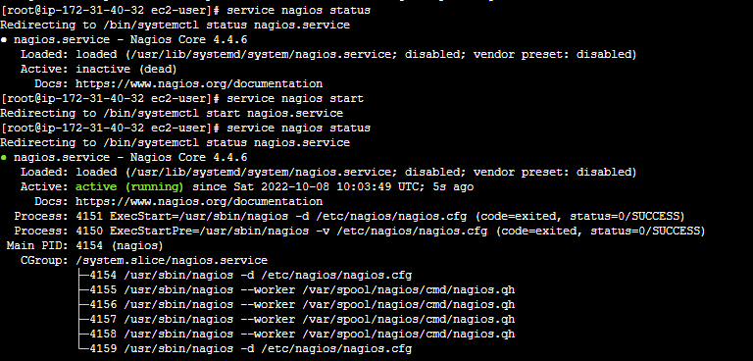

9) enable service



10) nagios monitoring tool

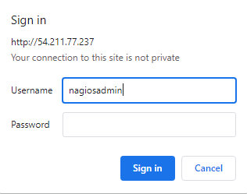

**Conclusion:-**